Medina Summer Wellness Day
The School Based Health Center at Akron Children’s Hospital is holding a Summer Wellness Day for all Medina school district students:
7/16/26

at Medina High School from 9 am to 2 pm

Students can get their yearly check-up, sports physical, employment physical, immunizations, or discuss other health care concerns.
To request an appointment, call 330-543-7242 or scan the QR code.
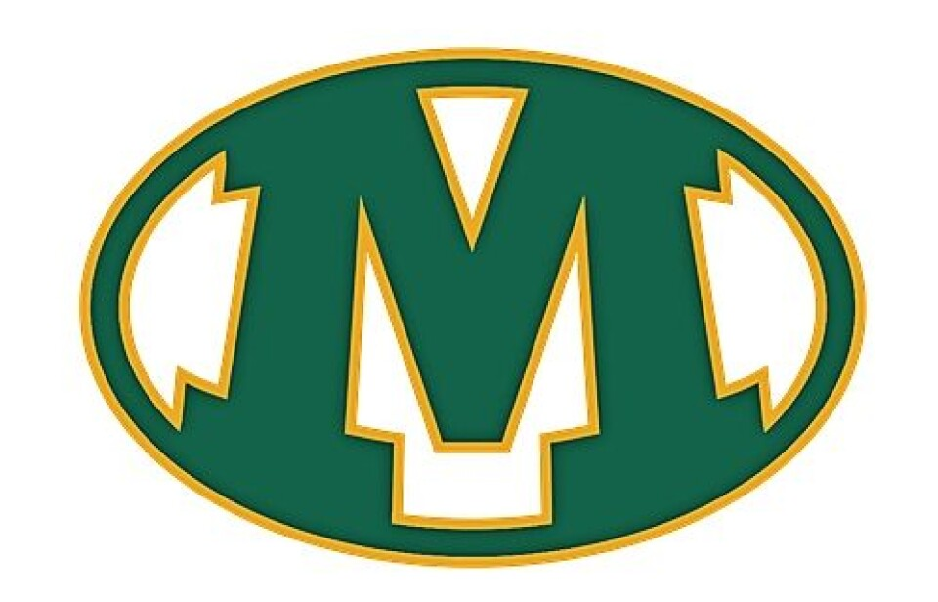
Bring completed sports/ employment forms and signed consent forms with you.

Services are billed to through medical insurance.
Financial counseling is available for those without insurance.

